LXXII . Relative Motion of Earth and AEther.
By A. A. Michelson .
Phil. Mag. S. 6. Vol. 8. No. 48. Dec. 1904. 3 D

IN the Physikalische Zeitschrift a method is proposed by W. Wien for deciding the important question of the trainement of the aether by the earth in its motion through space, by measuring the velocity of light in one direction— that is, without reflecting it back from the distant station.
The essentials in the proposed method are two Foucault mirrors, or two Fizeau wheels (one at each station) revolving at the same speed. The control for this synchronism is to be furnished by the “Konstanz des hindurchgehendes Lichtes oder in bekannten stroboskopischen Methoden.”
The flaw in the proposed method—as was pointed out by Simon Newcomb as long ago as 1880—lies in the fact that the effect which it is proposed to measure is exactly the same as the effect on the light which is to furnish the test of synchronism.
In November 1887 I proposed a method differing in no essential respect from the foregoing, except that the control of synchronism was to be furnished by electrical methods. This was before the celebrated work of Hertz showed that electrical impulses differed in no essential from light. This identity constitutes the same objection to this plan .
The possibility of a mechanical method of control was pointed out in a paper on the ‘‘Velocity of Light,” in the Philosophical Magazine, March 1902. This is based on some experiments made in 1899, which showed that the vibrations of a tuning-fork could be transmitted over a mile of piano-wire with but little diminution of amplitude .
Part II.
Suppose it were possible to transmit two pencils of light in opposite directions around the earth parallel to the equator, returning the pencils to the starting-point. If the rotation of the earth does not entrain the aether, it is clear that one of the two pencils will be accelerated and the other retarded (relatively to the observing apparatus) by a quantity proportional to the velocity of the earth’s surface, and to the length of the parallel of latitude at the place; so that a measurement of the difference of time required for the two pencils to traverse the circuit would furnish a quantitative test of the entrainement.
But it is not necessary that the path should encircle the globe, for there would still be a difference in time for any position of the circuit.
This difference is given by the formula
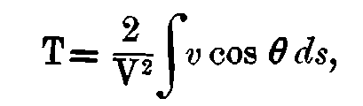
where V is the velocity of light, v the velocity of the earth's surface at the element of path ds, and θ the angle between v and ds.
If the circuit be horizontal, and x and y denote distances east and west and north and south respectively, and φ the latitude of the origin, and R the radius of the earth, then for small values of y/R we have approximately
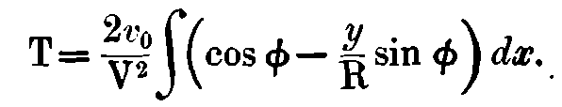
The integral being taken round the circuit the first term vanishes, and if A=∫ ydx = area of the circuit,
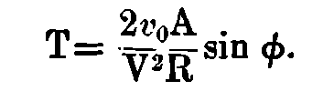
The corresponding difference of path for equal times expressed in light-waves of length λ is
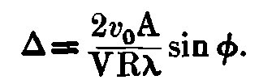
Thus, for latitude 45°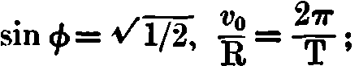the velocity
of light is 3 × 10⁸ in the same units, and the length of a light-wave is 5 × 10^{–7}; which approximate values substituted in the preceding formula give
Δ = 7 × 10^{–7}A.
Thus if the circuit be one kilometre square Δ=0.7.
The system of interference-fringes produced by the Superposition of the two pencils—one of which has traversed the circuit clockwise, and the other counterclockwise—would be shifted through seven-tenths of the distance between the fringes, in the direction corresponding to a retardation of
the clockwise pencil, if the experiment were tried in the Northern hemisphere.
The observation of interference-fringes produced by pencils which traversed a path 60 × 20 metres presented so little difficulty, that it seems quite feasible to proceed to much greater distances.
In the case considered, the length of the path would be four kilometres. If this length were doubled the area enclosed would be quadrupled and the expected displacement would be 2.8 fringes.
A difficulty in the measurement of this displacement lies in the fact that it cannot be reversed (as was the case in the experiment where the entire apparatus was rotated). A fiducial mark is, however, furnished by the image produced by one of the two pencils.
Thus let light, starting from a slit and rendered parallel by a collimator, fall on a glass plate the upper half of which is heavily silvered while the lower half is clear or lightly silvered.
The light transmitted by the lower half is reflected round the circuit, returning to the glass plate through which it passes to the observing telescope—while the reflected part traverses the circuit in the opposite sense, returning to the glass plate where it is reflected to the observing telescope, interfering with the former pencil.
Observing by reflexion from the upper half, the image of the slit is seen, and the cross-hair of the eyepiece is made to divide this image symmetrically. The upper half is now covered and the lower half clear.
The system of interference-fringes should have its central or achromatic fringe bisected by the cross-hair if the aether rotates with the earth. If the aether does not partake of the earth’s motion of rotation, the central fringe will be displaced from the cross-hair by the amount calculated from the formula.
A control is furnished by introducing another pair of mirrors in the path so as to make the area of the circuit so much smaller that the displacement would be negligible.
The attempt to apply the same principle to the revolution of the earth about the sun is less promising. The formula for the displacement from noon to midnight is in this case
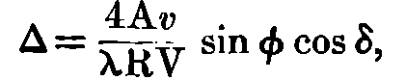
where A, λ, φ, and V have the same meaning as before, and

v is the velocity of the earth in its orbit, R the radius of earth’s orbit, and δ the sun’s declination.
If A = 10 × 10 kilometres,
v/V = 10^{–4}, R = 1.5 × l0¹¹, λ=5 × 10^{–7}, sin φ = 0.7, cos δ = 1, then Δ = 0.37.
To obtain this displacement would require a circuit 40 kilometres in length.

Communicated by the Author.
5 Jahrgang, No. 19, Seite 585-586
Possibly a spirally wound wire—which transmits electrical oscil¬lations with a velocity less than that of light—would be differently affected, and thus fnrnish a solution of the problem.
Perhaps, however, even mechanical impulses would be affected by the earth’s motion in such a way as to neutralize the expected effect.
Am. Journ. Sci. vol. iii. 1897.
Phil. Mag. Dec. 1887.

